**INSIGHTS & DATA ANALYSIS**

1. **Price-Volume-Cost**

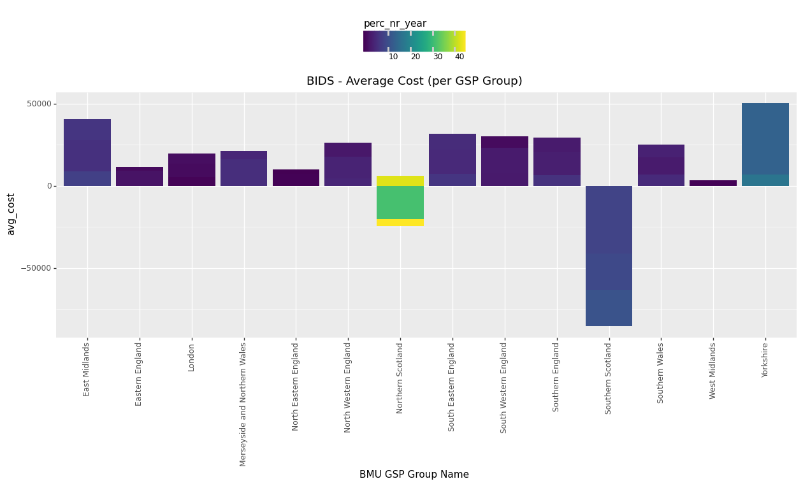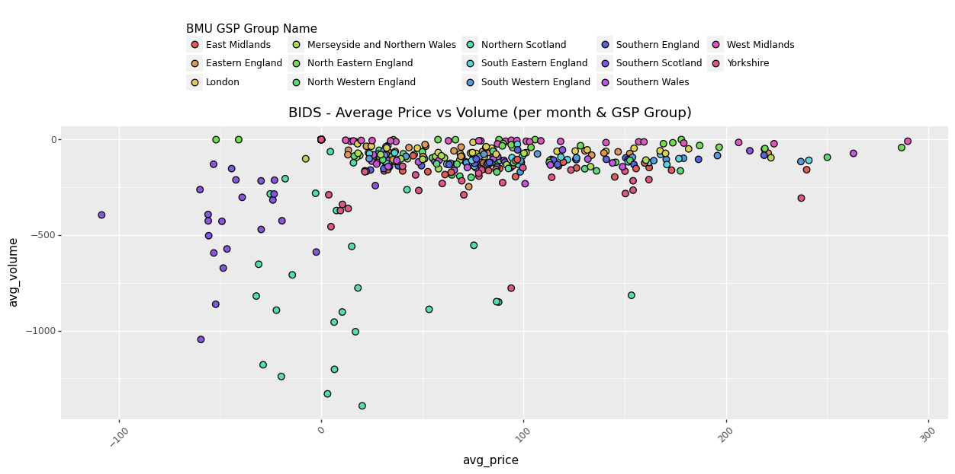

***Positive price/cost -> Party is paid by the BM Negative price/cost -> Party pays to the BM***

***Positive volume -> Party increase energy on the BM Negative volume -> Party decrease energy on the BM***

* Remarkable negative costs in Scotland (Northern Scotland and Southern Scotland) -> Party pays for energy reduction.

*Explanation: wind assets had an energy production planned which they cannot achieve, so they buy energy reduction “rights”.*

* Price-Volume trends (on the scatter plot): negative price + negative volume bids for Scotland’s regions.

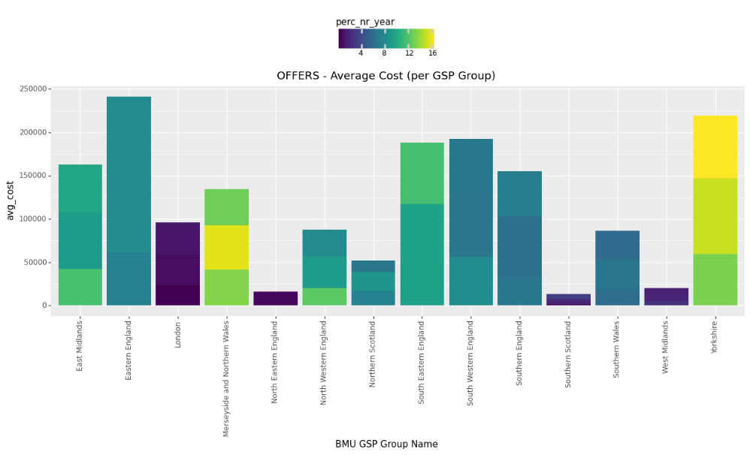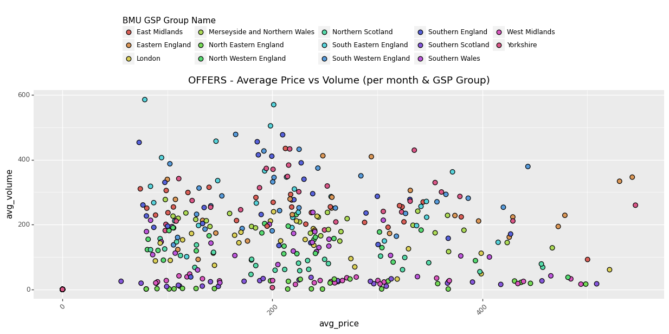

* Higher costs and Offers activity on the centre of England (East Midlands, Yorkshire, South of England).
* Noticeably lower Offer activity on the north regions.
* Price-Volume trends (on the scatter plot): higher offer volumes on the centre and south regions of England.

1. **Cost-Fuel type**

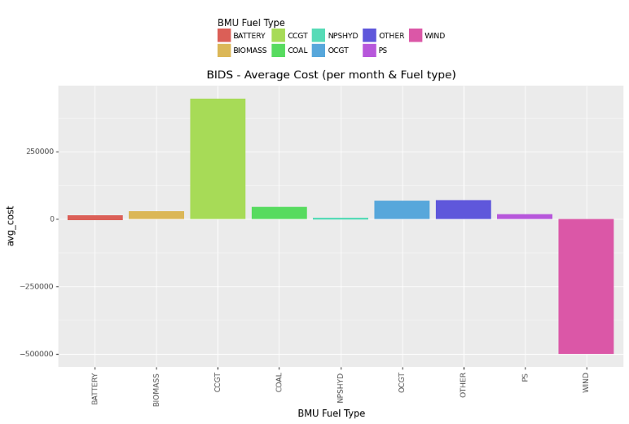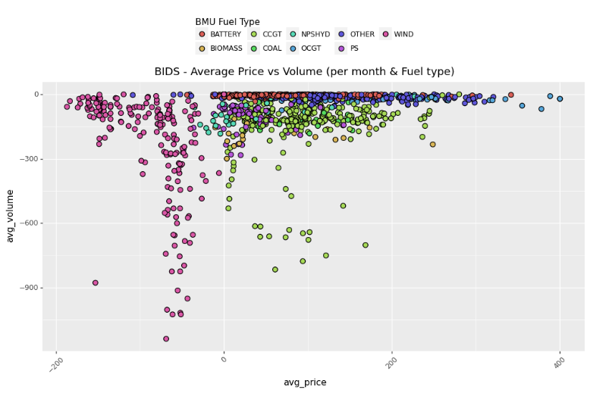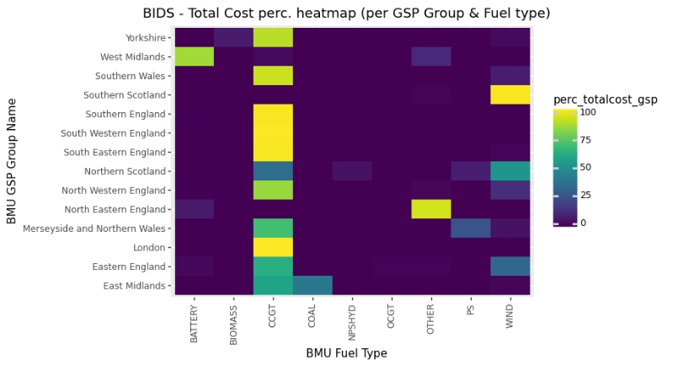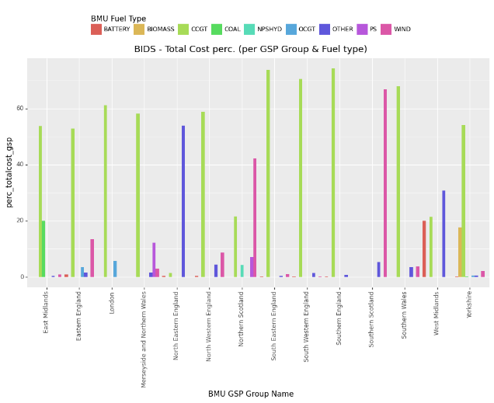

* Predominant presence of Gas (CCGT and OCGT) on the “positive price” Bids -> Party is paid for energy reduction.

*Explanation: gas plants are more flexible to energy generation changes.*

* Predominant presence of Wind on the “negative price” Bids -> Party pays for energy reduction.

*Explanation: wind assets had an energy production planned which they cannot achieve, so they buy energy reduction “rights”.*

* Predominant wind activity in the north (Northern Scotland and Southern Scotland).
* Predominant activity of other producers/consumers in North Eastern England.
* Remarkable batteries activity in the West Midlands region.

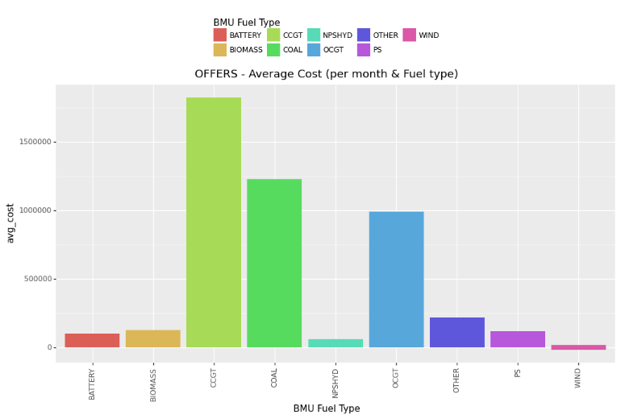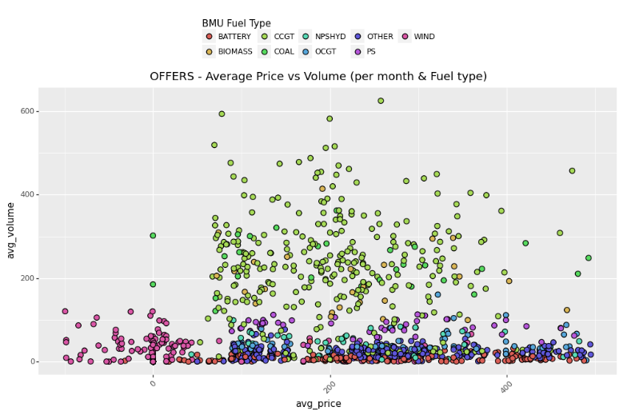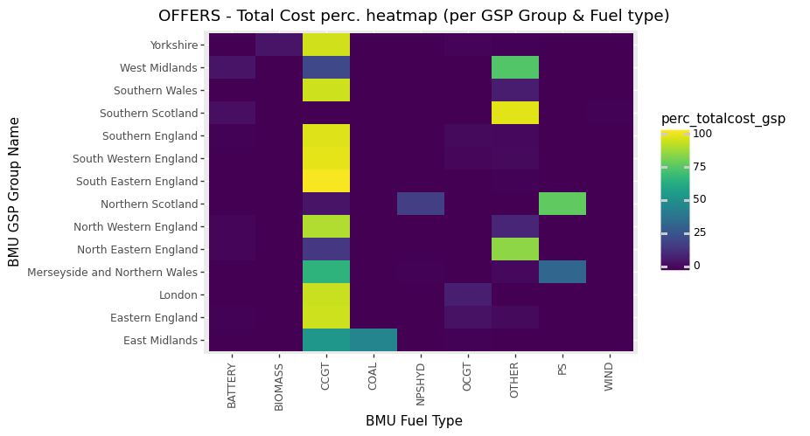 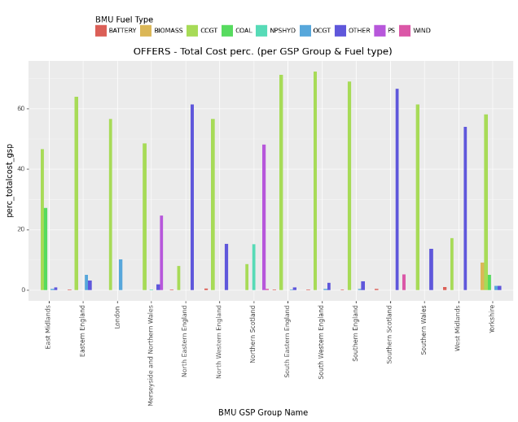

* Predominant presence of Gas (CCGT and OCGT) and Coal on the Offers -> Party is paid for energy increase

*Explanation: gas and coal plants are more flexible to energy generation changes.*

* Predominant activity of other producers/consumers in West Midlands, North Eastern England and Southern Scotland.
* Remarkable coal activity in the East Midlands region (only region with this type of assets still active).

1. **BMUs info**

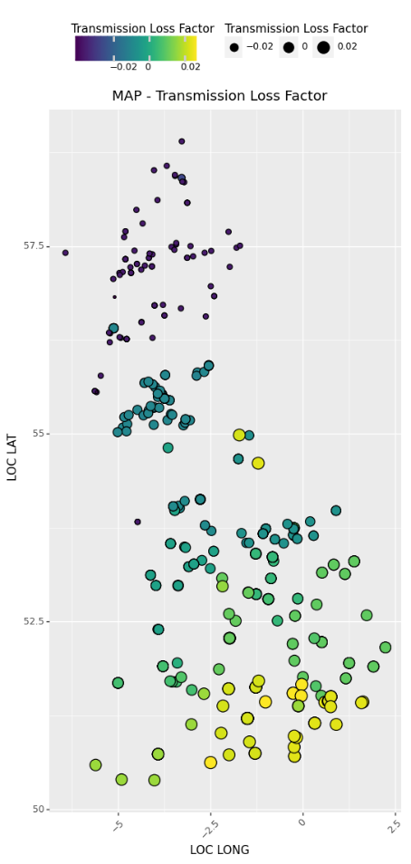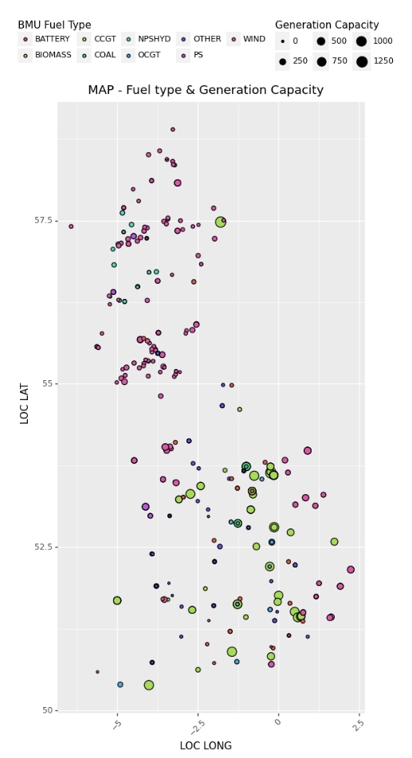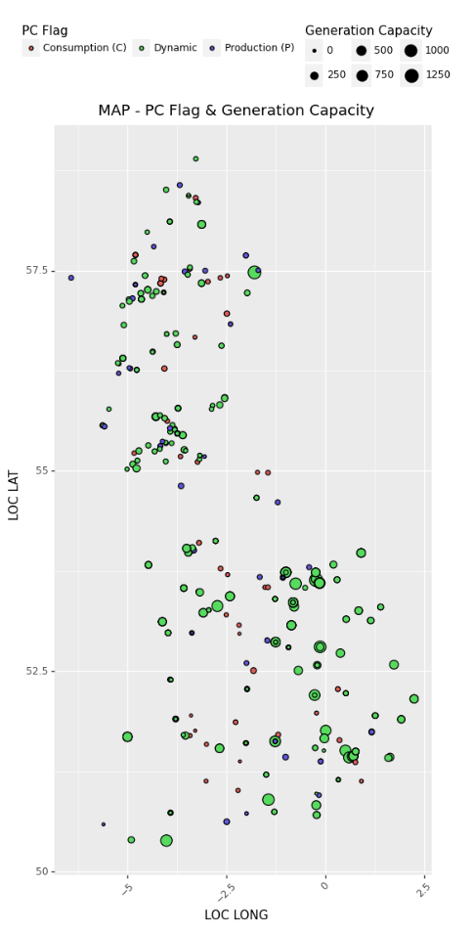Maps with all the active assets from 2021 till today:

**First map:**

* Cross information between Generation/Consumption/Both asset categorisation and generation capacity.
* Bigger producers mostly located on the south (England).
* More density of consumers on England as well.

**Second map:**

* Cross information between Fuel type asset categorisation and generation capacity.
* Gas/Coal (bigger producers) mostly located on the south (England).
* Wind mostly located on the north (Scotland).
* Remarkable presence of hydraulic assets in Northern Scotland.

**Third map:**

* Map representing the Transmission Loss Factor of all the assets.
* TLF -> Metric to reflect the electricity losses when energy is transmitted across the network.
* TLF is zone specific (there are 14 geographic zones, corresponding to the DNO
* zones) and vary at different times of year due to different flows and the weather.
* Gas/Coal (bigger producers) mostly located on the south (England).
* Wind mostly located on the north (Scotland).
* Assets with better TLF (positive, less transmission losses) are located on the south (England).

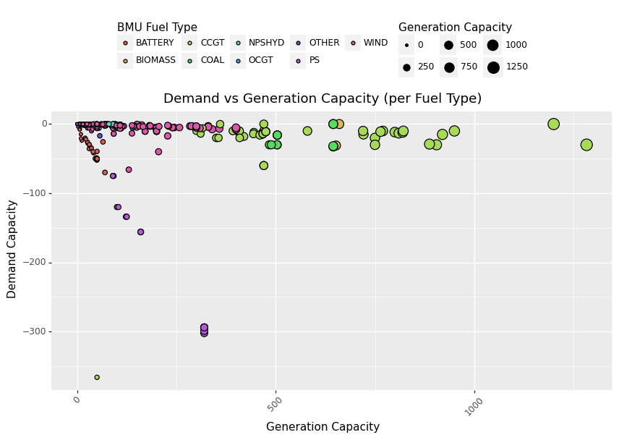

Plot showing the relation between demand and generation on the different assets taking part on the BM market.

* Gas assets are the most important in generation.
* Coal and Biomass assets are considerably big as well.
* Linear relation between demand and generation for batteries and pump storage assets.
* Pump storage assets are the most important ones regarding demand.

1. **Maps**



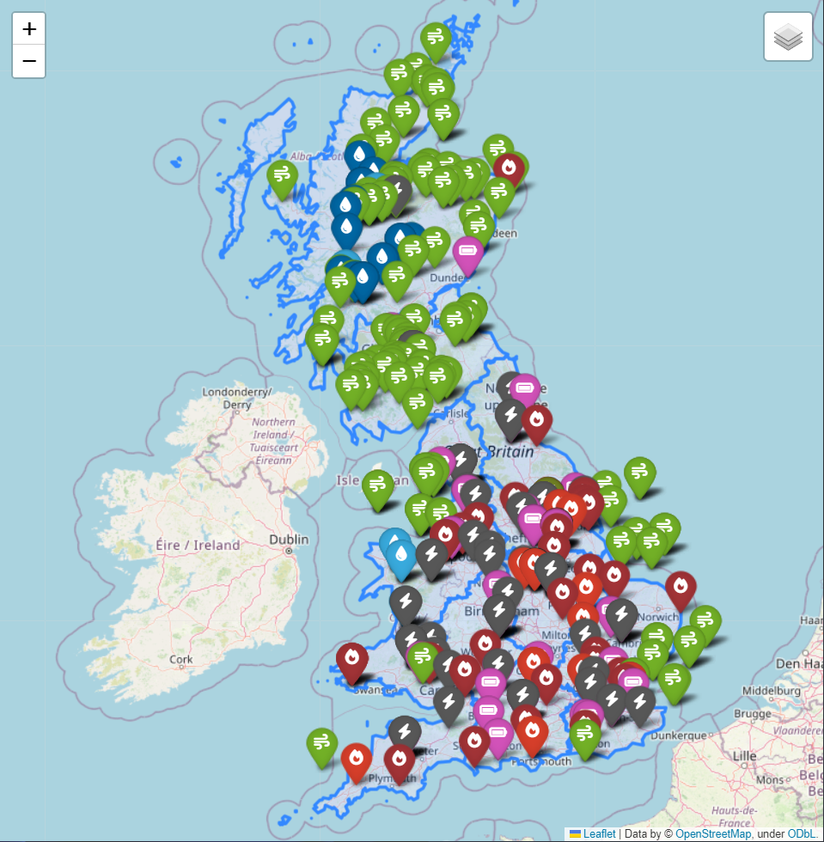

* Wind predominantly on the north (Northern Scotland and Southern Scotland).
* Except for the offshore wind farms on the northern coast of Wales and east and south coast of England.
* Southern Scotland almost all wind.
* Almost all hydraulic assets are concentrated on the north (Northern Scotland).
* Predominant presence of Gas plants on the center and south of UK (England and Wales).
* Presence of other types of assests on the center and south of UK as well, like batteries or flexible generators.

**CONCLUSIONS & NEXT STEPS**

* Continue with the deep analysis on the data (further statistical analysis, improve our knowledge on the market…).
* Complete dataset from the client (“Approved” and “Rejected” offers).
* Additional information from the Grid -> physical constraints (research and request to the client).
* Additional information from the Market when the bid/offer was made (research and request to the client).
* Data preparation and cleaning (outliers, missing values…).
* Start thinking about the most appropriate model and metric for the project.
* Start thinking how to prepare the data for the model (variables importance, categorical variables…).